# **C++ Multilevel Inheritance**

**Multilevel Inheritance in C++** is the process of deriving a class from another derived class. When one class inherits another class it is further inherited by another class. It is known as multi-level inheritance.

For example, if we take Grandfather as a base class then Father is the derived class that has features of Grandfather and then Child is the also derived class that is derived from the sub-class Father which inherits all the features of Father.

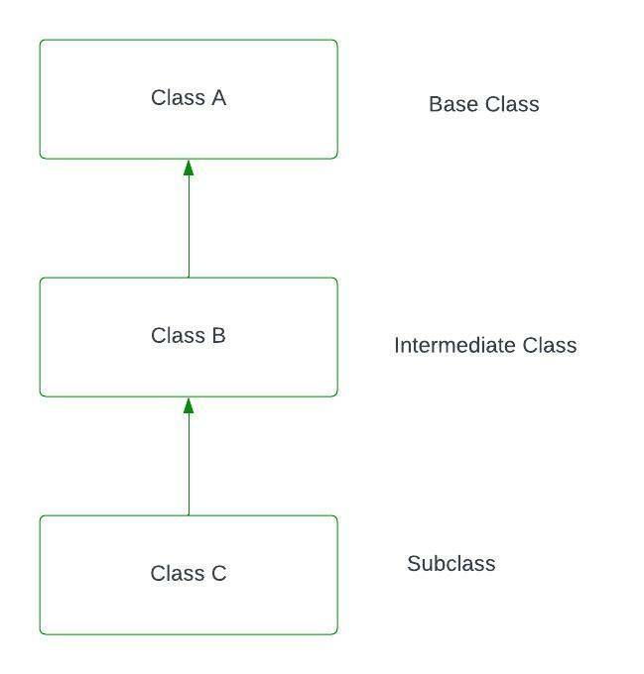

Syntax:

class A // base class

{

...........

};

class B : access_specifier A // derived class

{

...........

} ;

class C : access_specifier B // derived from derived class B

{

...........

} ;

// C++ program to implement

// Multilevel Inheritance

#include <bits/stdc++.h>

using namespace std;

// single base class

class A {

public:

int a;

void get_A_data()

{

cout << "Enter value of a: ";

cin >> a;

}

};

// derived class from base class

class B : public A {

public:

int b;

void get_B_data()

{

cout << "Enter value of b: ";

cin >> b;

}

};

// derived from class derive1

class C : public B {

private:

int c;

public:

void get_C_data()

{

cout << "Enter value of c: ";

cin >> c;

}

// function to print sum

void sum()

{

int ans = a + b + c;

cout << "sum: " << ans;

}

};

int main()

{

// object of sub class

C obj;

obj.get_A_data();

obj.get_B_data();

obj.get_C_data();

obj.sum();

return 0;

}